**Database Management and Entity-Relationship Diagram**

DBMS: The primes purpose of a relational database management system is to maintain data integrity.

Data integrity ensures the consistency and the accuracy of the data. It ensures that none of the data has been compromised in transmission or at the time of storage (wrong or inaccurate data entered).

Schema* is the overall design that emerges once each table is defined and the relationship between them is established.

The letters ERD stand for Entity relationship diagram. An example of an ERD is below:

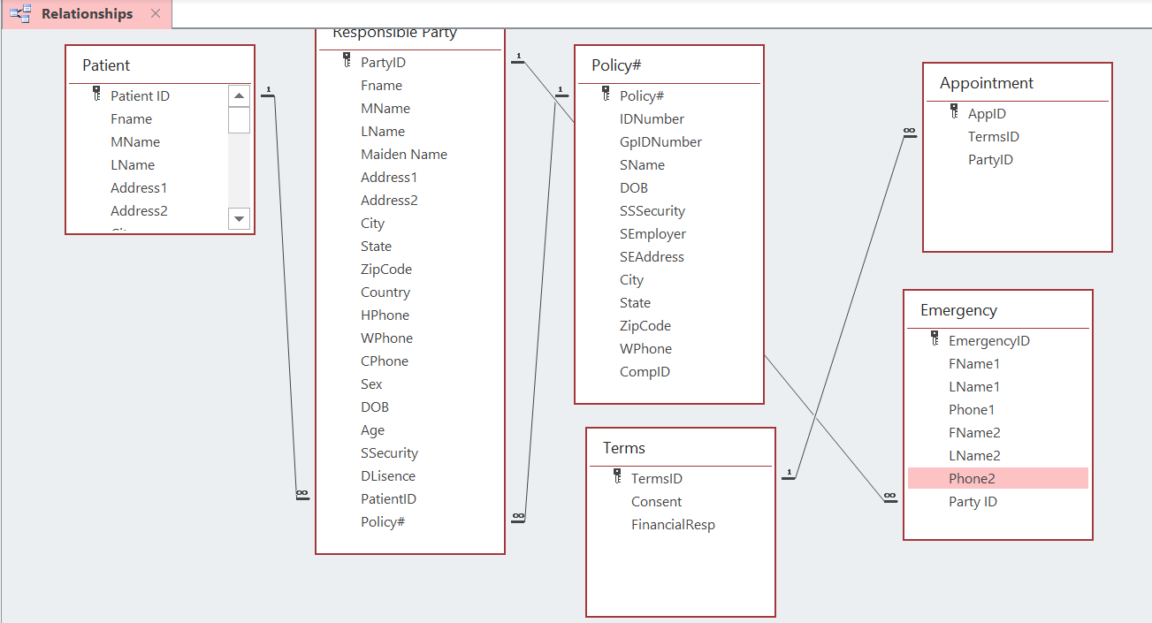

The three levels of the Schema:

* External level: The way the end user sees the database, the user is not able to modify the table. The external viewer is only the viewer, not the editor.
* Logical level: The level of the database administrator, he is the creator of the database. They have editing permissions; they do not see the data (as the external viewer sees it).
* Internal level: The physical levels of the data storage. This is hardware of the servers which store the data.

Referential integrity requires that a foreign key must have a matching primary key.

*Or in other words the overall aesthetics of the database